UFO Task – Data Cleansing

Goal : gain further practice with AWS QuickSight to cleanse and reformat a dataset which is text heavy, enabling you to produce both visual and text analyses. QuickSight does not provide a complete set of data cleaning features (other services for this exist in AWS e.g. Glue DataBrew).

Cleansing actions:
- Join two data files into a single dataset
- Extract spatial data from text
- Create a geospatial hierarchy to avert incorrect GIS search queries
- Manage inconsistent text data with calculations and groups
- Amend detected data types
- Exclude unused fields

Steps

Task 1 – create and publish the dataset
- Create a new dataset in QuickSight, by uploading the file UFOGB_Details.csv
- Edit the data set (do not go straight into publish and visualise)
- Add data, to bring in the next source, the uploaded file – UFO_Comments.csv
- Join the two source tables using ID as the join key, INNER join type. 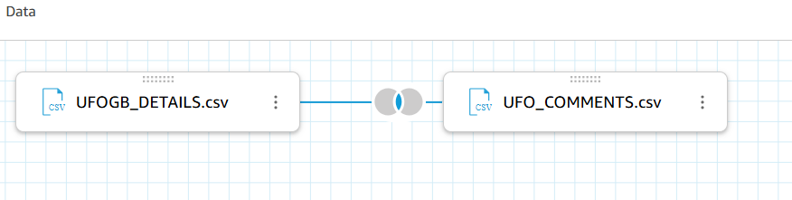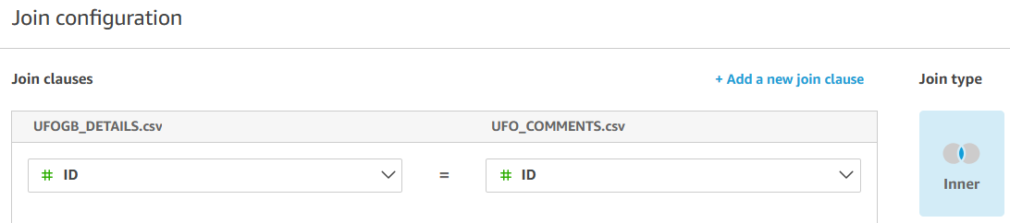
- Exclude one of the ID fields that is stored as a duplicate after the join.

Task 2 – explore the data and visual capabilities
- Publish the dataset and visualise so that you can spend time exploring the data
- Experiment with visualisations including a point map using the existing columns, noting the inconsistent text values and formatting.

Task 3 – convert to a real date
- Note that the SIGHTING_DATE field has been detected as a string, rather than a Date type. The format of the date is US.

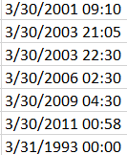
- Create a new column using the Add Calculated Field option.

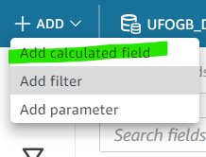
- Use the parseDate function to resolve this problem in the calculation with the following formula, which accepts the incoming string format and converts it to a true date value.
parseDate({SIGHTING_DATE}, 'MM/dd/yyyy HH:mm')
- You can choose to type the function and field name, ensuring that you use the correct punctuation and spelling, or you can use the functions and field menus on the right-hand side of your screen to double click and drop into the calculated field editor.
- Name the column cf_object_sighted.
- This new column will be automatically detected as Date type.

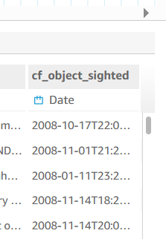

Task 4 – extract the hour of sighting
- Use the new date field to create a new field and use the function extract to pull out the hour of the observation (which return an integer as a 24-hour clock) in a new calculated field.
extract(‘HH’,{cf_object_sighted})

- Name this new column cf_hour_sighted

Task 5 – focus on geographical information
- We want to plot the location of the sighting on the map, so we need to retrieve city and country from the data. City is found inside the field CITY_STATE but there is a consistent pattern in the text values: the city is typed before the brackets are opened. We can use this pattern to our advantage and take the first chunk of text before brackets, dropping any spaces.

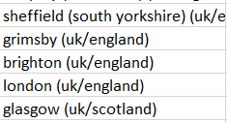
- Add a new calculated field called cf_city and use the function split to extract City name from the data. As before, you can choose to type the function and field name, ensuring that you use the correct punctuation and spelling, or you can use the functions and field menus on the right-hand side of your screen to double click and drop into the calculated field editor.
split({CITY_STATE}, “(“,1)
- Once cf_city is created, assign a spatial role to the column of City
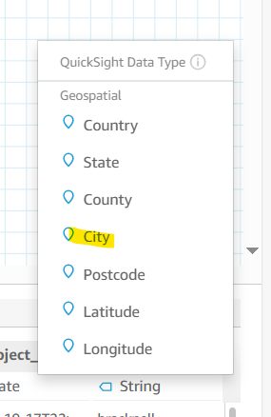
- For the country, we already have a field we can use (COUNTRYCODE) – use the 3 dots on the column COUNTRYCODE in the Fields menu to edit the name of the field (change to lower case for consistency) and change the data type to Country. Be careful not to accidentally choose County!
- Using the same 3 dot menu, Add to Hierarchy to create a new geospatial hierarchy called country-city. This will ensure when creating a visual map of the UFO sightings that QuickSight looks for those city names in Great Britain rather than another country.
- The hierarchy feature provides an opportunity to set a single country – United Kingdom – or allow for multiple countries. Either option in this case will be fine.
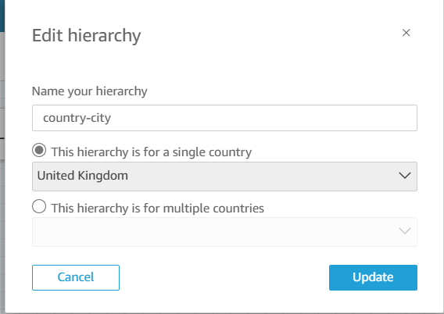
- Add the city field to the same hierarchy using the 3 dots next to city in the Fields list. Check and confirm the hierarchy looks correct in the field list (countrycode should be above city)
- In case we are interested in whether a sighting was in England, Wales or Scotland, we can also extract this information from the CITY_STATE column with another function replace, plus split. This works in most cases.
replace(split({CITY_STATE},"/",2),")","")
- Name this new calculated field cf_region.

Task 6 – new classification of objects
- Create a new calculated field to pick up some information from the comments field – for use in a filter on our analysis. This field works as a flag field, highlighting those observations which were reported as moving rapidly by the use of similar words.
- Use ifelse function to combine multiple alternative terms in the text which indicate the same movement. Save the calculated field as cf_moving_fast.
ifelse( contains({comments},"fast", CASE_INSENSITIVE)
OR contains({comments},"quick", CASE_INSENSITIVE)
OR contains({comments},"rapid", CASE_INSENSITIVE)
OR contains({comments},"swift", CASE_INSENSITIVE)
OR contains({comments},"high speed", CASE_INSENSITIVE),
"fast", "not_fast")

Task 7 – exclude unused fields
- Use the exclude field option from the menu on the following columns before publishing the dataset ready for analysis :
ID, SIGHTING_DATE, CITY_STATE, DATE_POSTED

